Host Complex Test Procedure

v0.2

## Port number definition

* For MINI-SAS HD port, 1 to 12 from left to right(the 12 MINI-SAS HD ports in the middle)
* For RJ45 port, 1 for lower, 2 for upper
* For USB port, 3-2:1.0 for lower, 3-14:1.0 for upper

## Test setup

For test setup, please refer to Wolf_Creek_EVT_Pre-Ship_Test_Plan.

## Test procedure

**Please finish SAS complex test before doing the following test.**

* For ‘BIOS FW Test’, check if BIOS version is correct(0100 in this example)

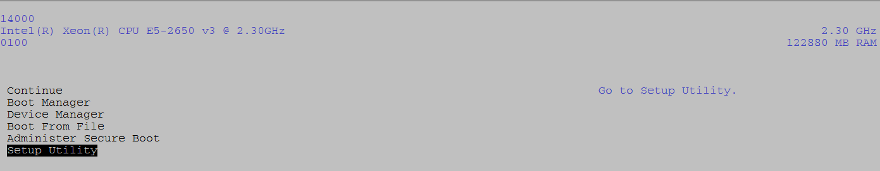

* For ‘CPU & Memory information test’

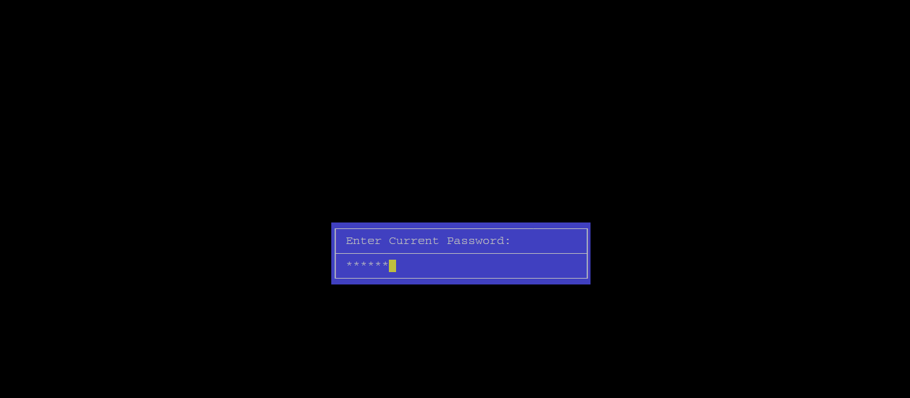

Password: c411ie

Check memory size installed with golden sample. Size in this example is incorrect, so FAIL.

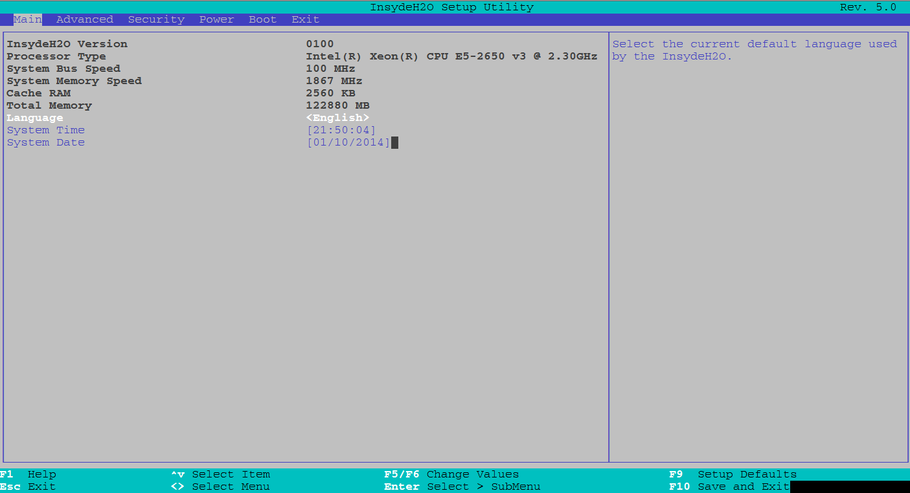

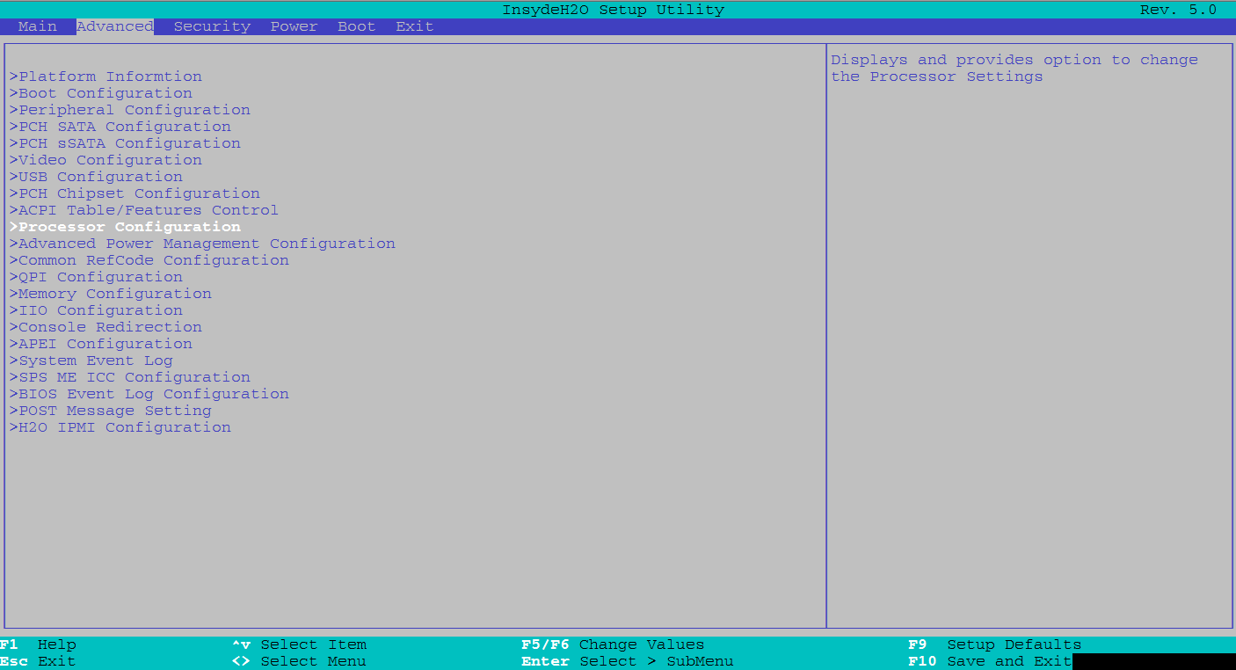

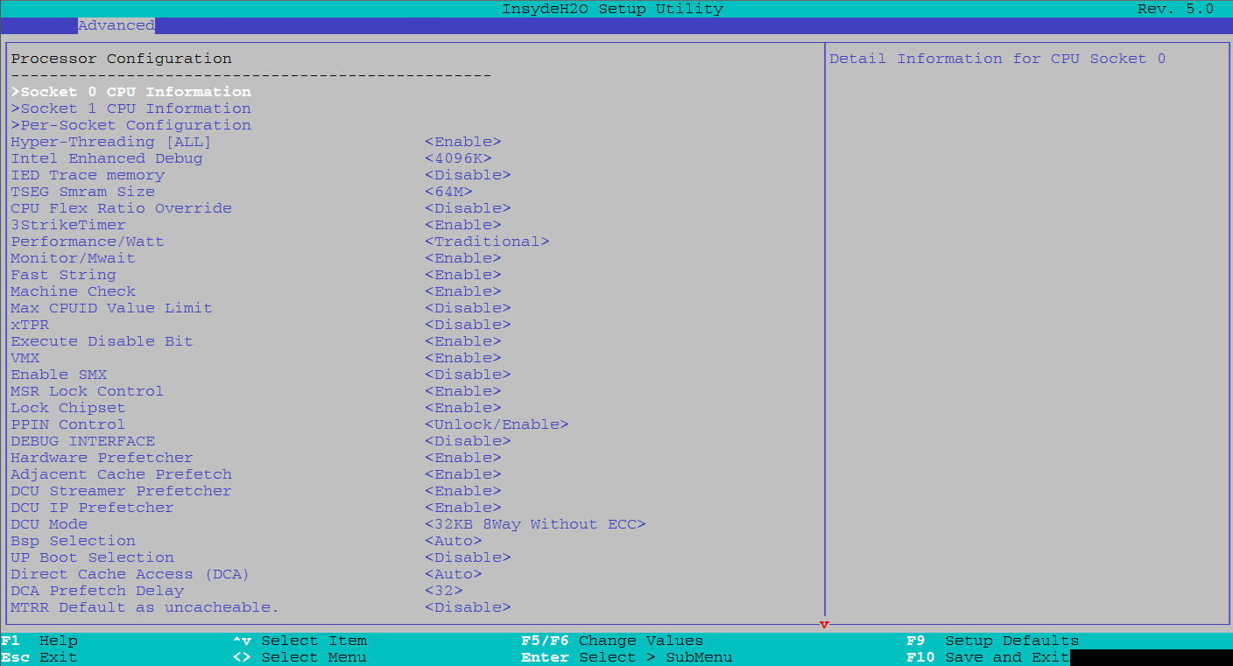

Check processor information, only socket 0 shown here, the same steps to socket 1. For processor information, please check with golden sample.

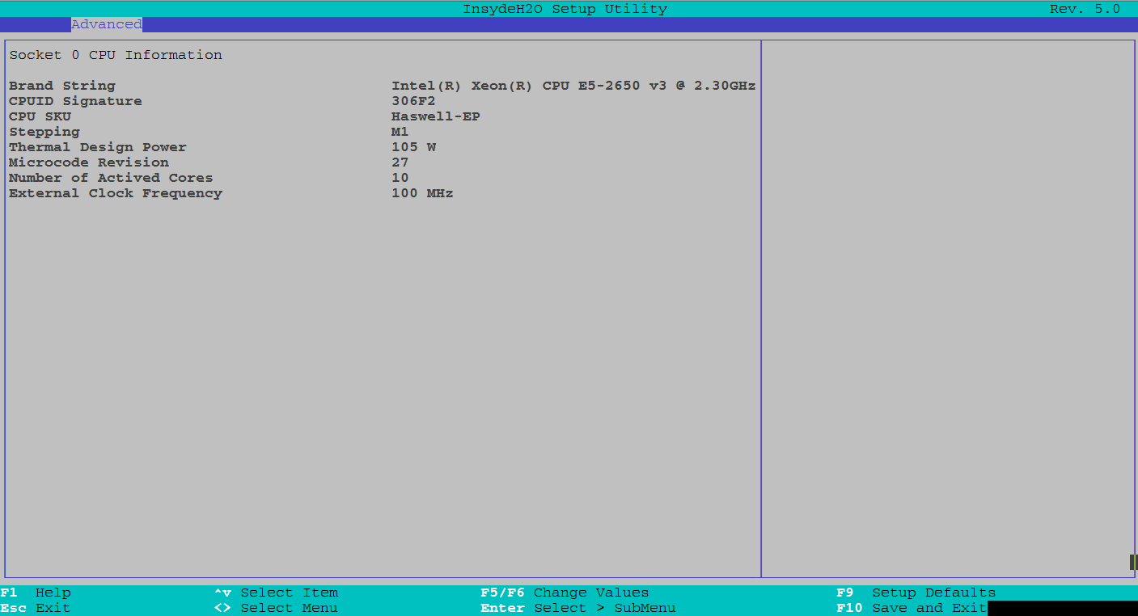

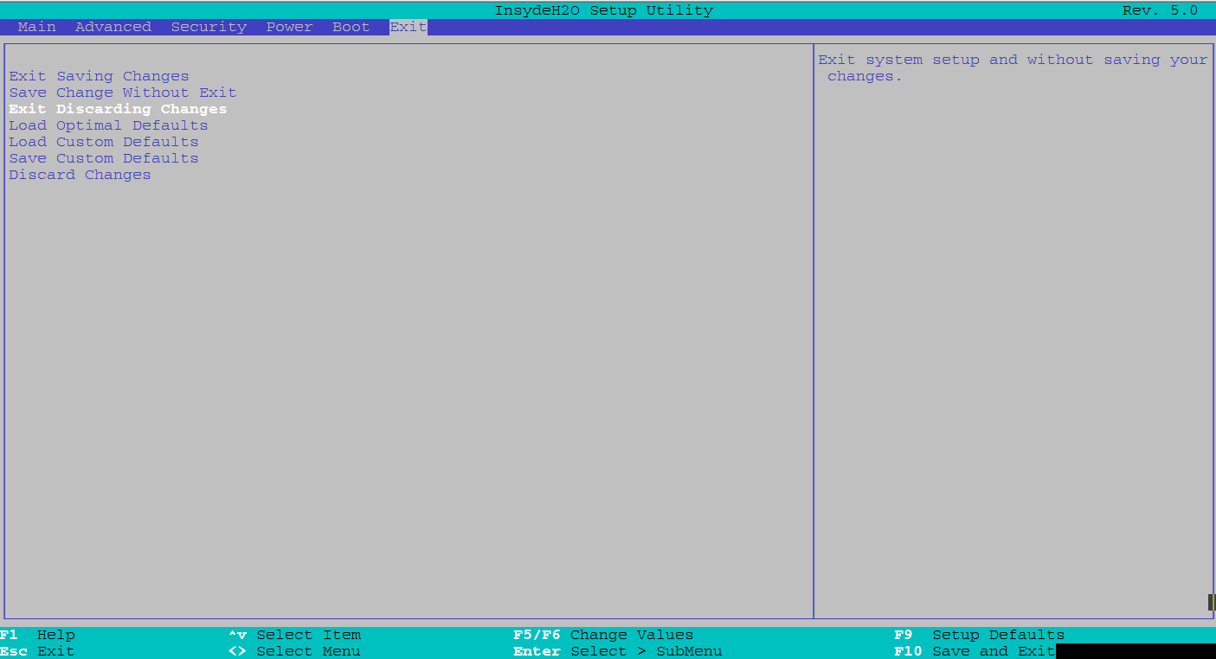

* For ‘Boot test’

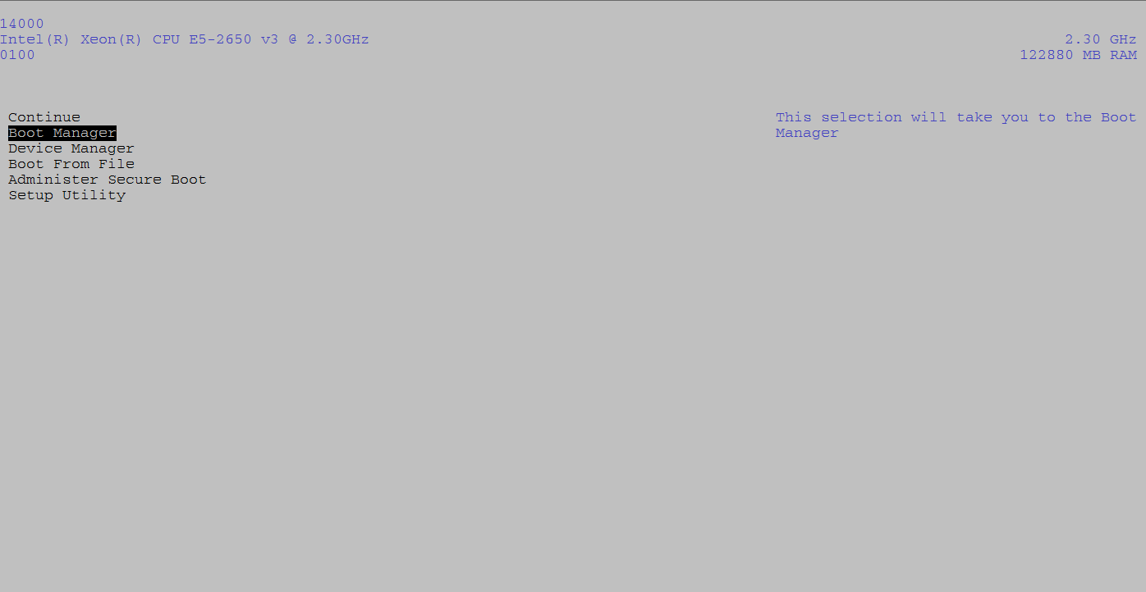

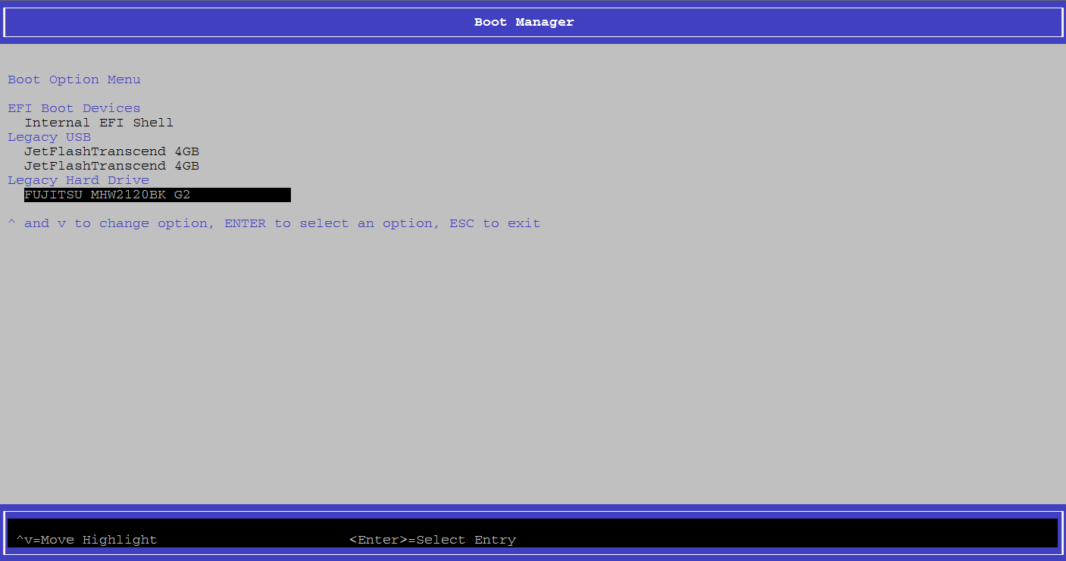

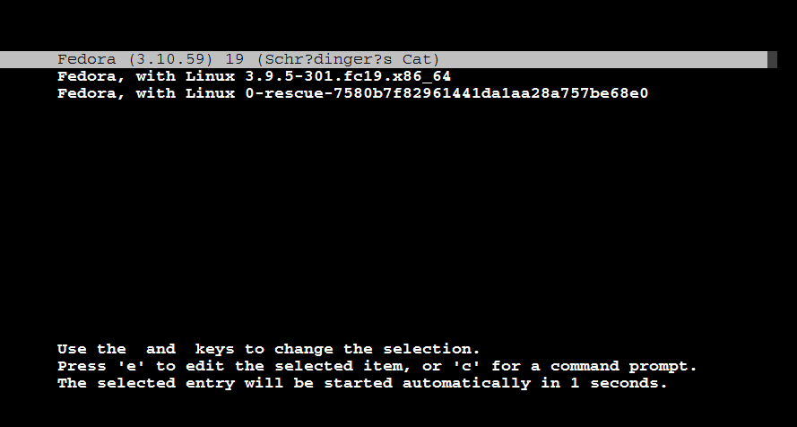

Boot up successfully when see following screen.

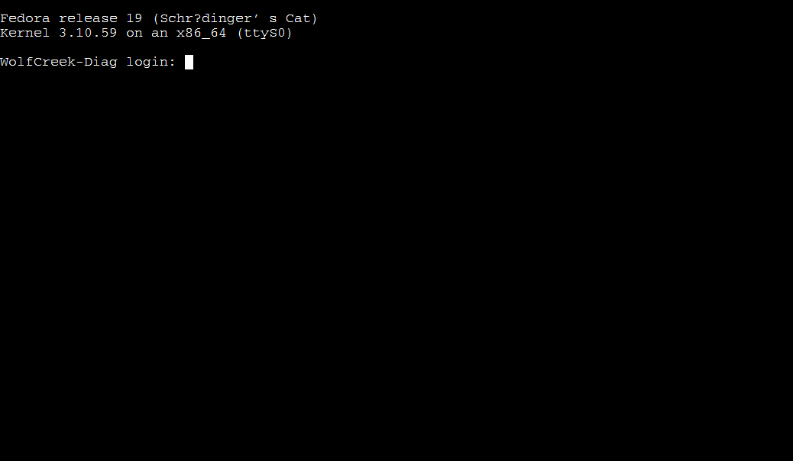

Username: root

Password: 111111

* For ‘PCIe test’, ‘Mini-SAS HD port test’, ‘PCIe slot test’, ‘Clock test’, ‘USB port test’, ‘720 HDD test’, ‘Memory Stress test’ run the following test script. All these tests are defined in Wolf_Creek_EVT_Pre-Ship_Test_Plan. 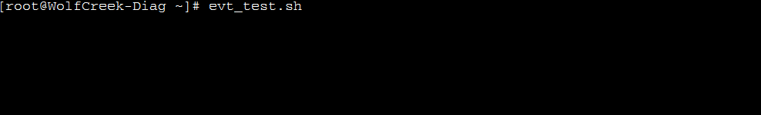

After each run of individual test, the execution of test script will stop until an ‘Enter’ is input. Looks like:

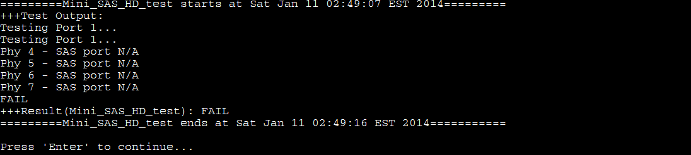

* For ‘Ethernet test’ defined in Wolf_Creek_EVT_Pre-Ship_Test_Plan. To test lower RJ45 port



Output looks like(PASS in this case)

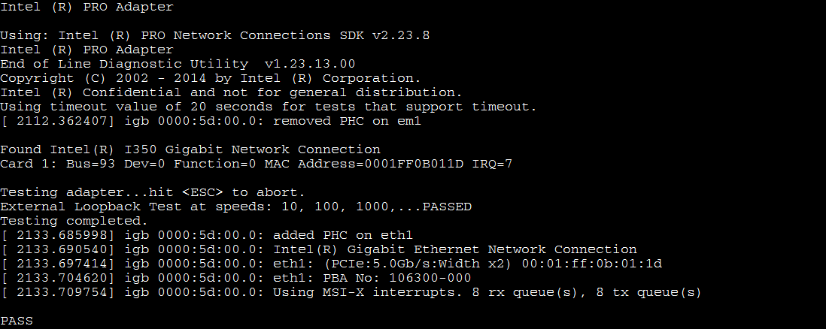

To test upper RJ45 port



Output looks like(Fail in this case)

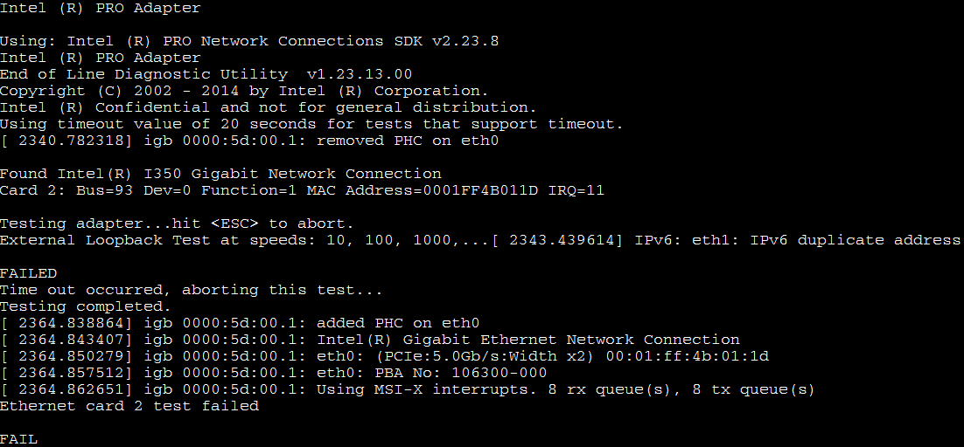

* For System power cycle test(cover internal HDD test)

1. Plug out all power cables, change booting HDD to another internal HDD slot. And then plug in all power cables. And then run(Fail in this case)

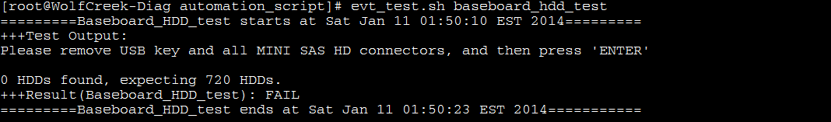

1. Repeat step 1 4 times. (all 4 internal HDD slots tested)

**Note: the HDDs found in each run should be recorded.**

## For reproducing Individual test

Load drivers first

To run PCIe test

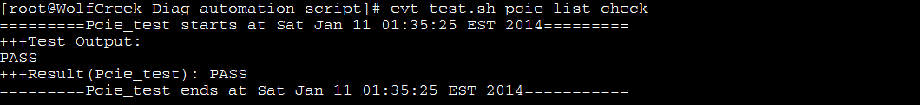

To run MINI-SAS HD port test, port number from 1 to 12

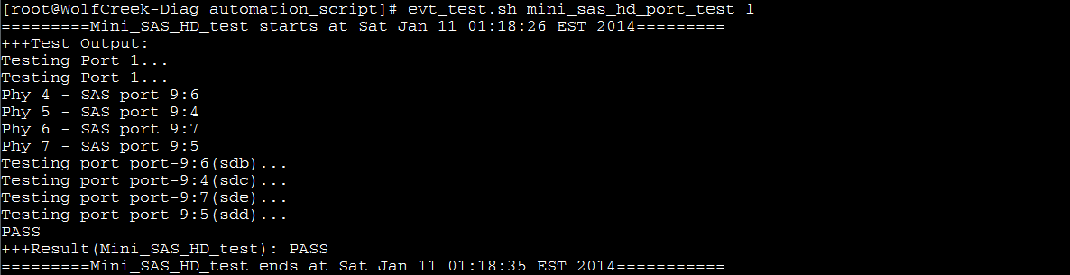

To run pcie slot test(infiniband)

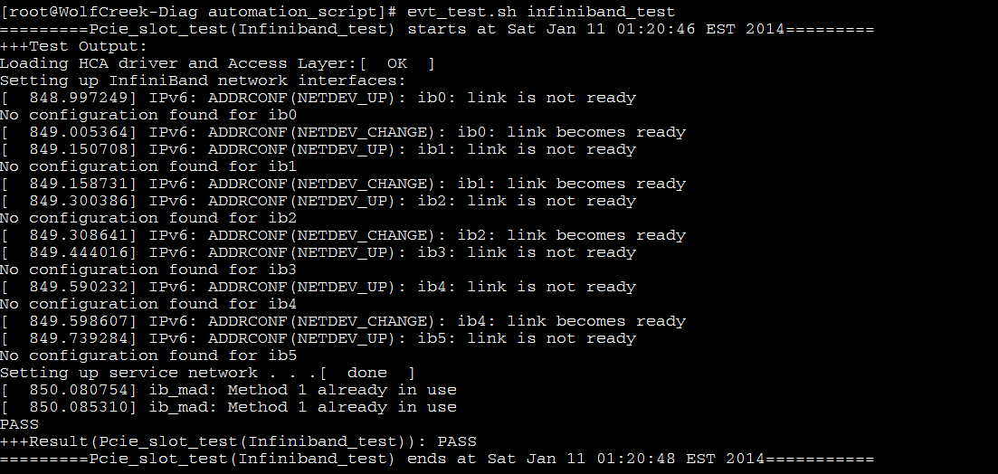

To run clock test

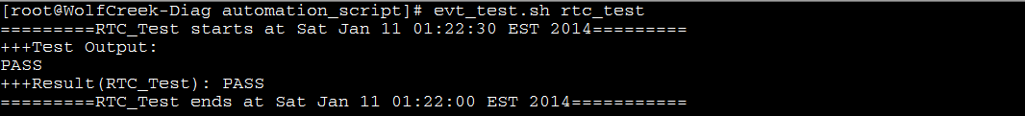

To run usb port test on upper usb port

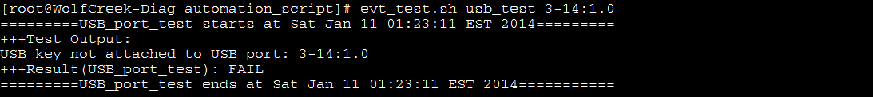

To run usb port test on lower usb port

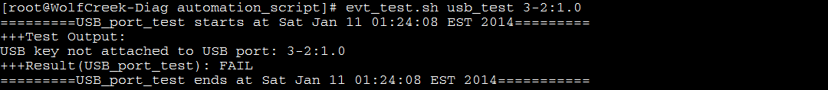

To run baseboard 720 HDDs test

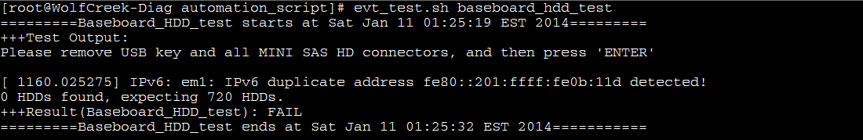

To run memory stress test(test not finished in this example)

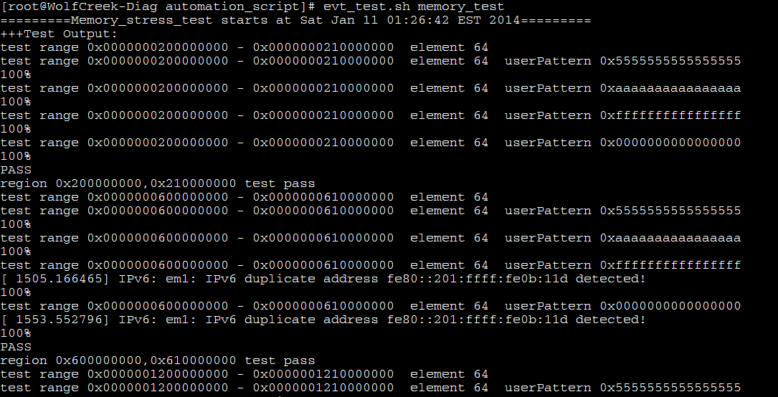

Command line can be found in /usr/local/diag/bin/evt_test.sh, run following command to see content of this script.



## Test Result

Result of every test look like the following. It contains start time and end time, test output and PASS/FAIL as test result. Please be noted, the line

*+++Result(test name):PASS*

Shows the final result of a test.

